INTRODUCTION TO DATABASES PROJECT

PHASE 2



Şerefim ve inandığım tüm değerler adına yemin ederim ki bu sınavda hiçbir yerden kopya çekmedim ve etik kurallarına karşı gelmedim.

I swear on behalf of my honor and all the values I believe in that I did not cheat in this exam from anywhere and I did not violate the ethic rules.

MYM FOOTBALL FEDERATION

MERİÇ ASLAN – 138720007

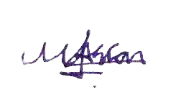 kişi, gömlek, genç, poz içeren bir resim

Açıklama otomatik olarak oluşturuldu

MEHMET KESTEK – 138721508

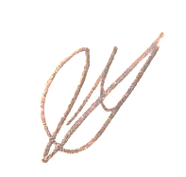 kişi, duvar, adam, poz içeren bir resim

Açıklama otomatik olarak oluşturuldu

MUHAMMED YUSUF LALE – 138720012

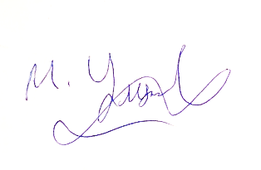 kişi, duvar, iç mekan, adam içeren bir resim

Açıklama otomatik olarak oluşturuldu ASSOC.PROF Selçuk KIRAN

FOOTBALL CLUB’S DBMS

Description Of The Project

In our database model, we would like to analyze a football team. As we explained at the “Entities” part, we take a look at the main elements of a football club such as facilities, players, pilot clubs, club employees, achievements, equipment, player’s managers, transfers and fans.

We have written our business rules sentence by sentence. Then we explained our entities. After the part of "Data Dictionary", we drew the diagram. In this way, we tried to explain the structure of a football club.

Entities:

1) Club: a football team competing in a country's football league.

2) Facilities: Areas where players prepare for competitions, where matches are played and which clubs use administratively.

3) Players: Athletes performing in a football club.

4) Pilot Club: According to the agreement between the top teams, usually the players of the lower teams, facilities, etc. benefit from.

5) Club employees: Persons who perform financial, administrative and similar duties.

6) Financial Status: The sum of a club's income and expenses.

7) Achievement: All the medals and trophies that a club receives as a result of the competition are called.

8) Sports Equipment: All inventories that players use during matches or during training.

9) Managers: These are the people who represent the football player, arrange transfer negotiations and negotiate with the necessary teams and arrange the transfer.

10) Transfers: The acquisition of a player by another club at a cost.

11) Fans: Supporters of any sports club are called.

Business Rules:

1) Clubs compete in the leagues of the country they are in.

2) Each team must have a minimum of 15 and a maximum of 28 players..

3) Every club must have a chairman of the board, security officer, stadium manager.

4) Clubs must notify the federation in which stadium they will play before the season starts.

5) Every player must have a manager.

6) A player cannot have two or more managers.

7) A manager can work with more than one player.

8) Every manager must have a phone number and e-mail address for communication.

9) Clubs must provide the equipment that the players will use in the matches.

11) If a different club makes an offer to a player in the pilot club along with the main club, the main club has priority.

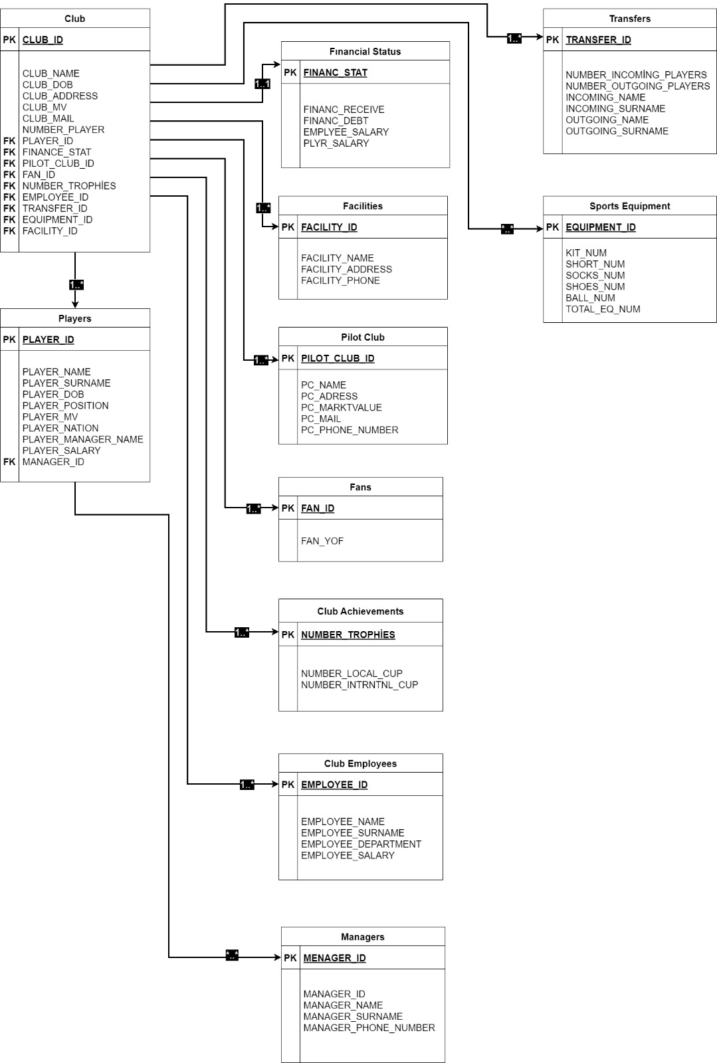

tablo içeren bir resim

Açıklama otomatik olarak oluşturulduDATABASE

DROP TABLE Club

DROP TABLE Players

DROP TABLE ClubAchievements

DROP TABLE SportEquipments

DROP TABLE Transfers

DROP TABLE ClubEmployees

DROP TABLE Facilities

DROP TABLE Managers

DROP TABLE Fans

DROP TABLE PilotClub

DROP TABLE Finance

CREATE TABLE Finance (

FINANCE_STAT int PRIMARY KEY NOT NULL,

FINANC_RECEİVE int DEFAULT(0),

FINANC_DEBT int DEFAULT(0),

EMPLYEE_SALARY int DEFAULT(0) ,

PLYR_SALARY int DEFAULT(0)

)

CREATE TABLE PilotClub (

PILOT_CLUB_ID int PRIMARY KEY NOT NULL,

PC_NAME nvarchar(30),

PC_ADRESS nvarchar(100),

PC_MARKET_VALUE int,

PC_MAIL nvarchar(60),

PC_PHONE_NUMBER nvarchar(25)

)

CREATE TABLE Fans (

FAN_ID int PRIMARY KEY NOT NULL,

FAN_YOF date

)

CREATE TABLE Managers (

MANAGER_ID int PRIMARY KEY NOT NULL,

MANAGER_NAME nvarchar(30) NOT NULL,

MANAGER_SURNAME nvarchar(30) NOT NULL,

MANAGER_PHONE_NUMBER nvarchar(25)

)

CREATE TABLE Facilities (

FACILITY_ID int PRIMARY KEY NOT NULL,

FACILITY_NAME nvarchar(30) NOT NULL,

FACILITY_ADDRESS nvarchar(100) NOT NULL,

FACILITY_PHONE nvarchar(25)

)

CREATE TABLE ClubEmployees (

EMPLOYEE_ID int PRIMARY KEY NOT NULL,

EMPLOYEE_NAME nvarchar(30) NOT NULL,

EMPLOYEE_SURNAME nvarchar(30) NOT NULL,

EMPLOYEE_DEPARTMENT nvarchar(50) NOT NULL,

EMPLOYEE_SALARY int NOT NULL,

)

CREATE TABLE Transfers (

TRANSFER_ID int PRIMARY KEY NOT NULL,

NUMBER_INCOMİNG_PLAYERS int DEFAULT(0),

NUMBER_OUTGOING_PLAYERS int DEFAULT(0),

INCOMING_NAME nvarchar(30),

INCOMING_SURNAME nvarchar(30),

OUTGOING_NAME nvarchar(30),

OUTGOING_SURNAME nvarchar(30)

)

CREATE TABLE SportEquipments (

EQUIPMENT_ID int PRIMARY KEY NOT NULL,

KIT_NUM int DEFAULT(0),

SHORT_NUM int DEFAULT(0),

SOCKS_NUM int DEFAULT(0),

SHOES_NUM int DEFAULT(0),

BALL_NUM int DEFAULT(0),

TOTAL_EQ_NUM int DEFAULT(0)

)

CREATE TABLE ClubAchievements (

NUMBER_TROPHİES int PRIMARY KEY NOT NULL,

NUMBER_LOCAL_CUP int,

NUMBER_INTRNTNL_CUP int

)

CREATE TABLE Players (

PLAYER_ID int PRIMARY KEY NOT NULL,

PLAYER_NAME nvarchar(30) NOT NULL,

PLAYER_SURNAME nvarchar(30)NOT NULL,

PLAYER_DOB date,

PLAYER_POSITION nvarchar(20),

PLAYER_MV int,

PLAYER_NATION nvarchar(30),

PLAYER_MANAGER_NAME nvarchar(60),

PLAYER_SALARY int,

MANAGER_ID int,

CONSTRAINT fk_mng FOREIGN KEY(MANAGER_ID) REFERENCES Managers(MANAGER_ID)

)

CREATE TABLE Club (

CLUB_ID int PRIMARY KEY NOT NULL,

CLUB_NAME nvarchar(30) NOT NULL,

CLUB_DOB date NOT NULL,

CLUB_ADDRESS nvarchar(100),

CLUB_MV int,

CLUB_MAIL nvarchar(60),

NUMBER_PLAYER int NOT NULL,

PLAYER_ID int NOT NULL,

FINANCE_STAT int NOT NULL,

PILOT_CLUB_ID int NOT NULL,

FAN_ID int NOT NULL,

NUMBER_TROPHİES int NOT NULL,

EMPLOYEE_ID int NOT NULL,

TRANSFER_ID int NOT NULL,

EQUIPMENT_ID int NOT NULL,

FACILITY_ID int NOT NULL,

CONSTRAINT fk_fac FOREIGN KEY(FACILITY_ID) REFERENCES Facilities(FACILITY_ID),

CONSTRAINT fk_finance FOREIGN KEY(FINANCE_STAT) REFERENCES Finance(FINANCE_STAT),

CONSTRAINT fk_pilot FOREIGN KEY(PILOT_CLUB_ID) REFERENCES PilotClub(PILOT_CLUB_ID),

CONSTRAINT fk_fan FOREIGN KEY(FAN_ID) REFERENCES Fans(FAN_ID),

CONSTRAINT fk_emp FOREIGN KEY(EMPLOYEE_ID) REFERENCES ClubEmployees(EMPLOYEE_ID),

CONSTRAINT fk_trans FOREIGN KEY(TRANSFER_ID) REFERENCES Transfers(TRANSFER_ID),

CONSTRAINT fk_eq FOREIGN KEY(EQUIPMENT_ID) REFERENCES SportEquipments(EQUIPMENT_ID),

CONSTRAINT fk_ply FOREIGN KEY(PLAYER_ID) REFERENCES Players(PLAYER_ID),

CONSTRAINT fk_trop FOREIGN KEY(NUMBER_TROPHİES) REFERENCES ClubAchievements(NUMBER_TROPHİES)

)

DATA ENTERED IN TABLES

INSERT INTO Club

VALUES ( 1905 , 'GALATASARAY' , '1905-10-01' , 'ALİ SAMİ YEN SPOR KOMPLEKSİ HUZUR MAH. SEYRANTEPE/SARIYER' ,

141000000 , 'galatasaray1905@gmail.com' , 29 , 93 , 125000000 , 1 , 905 , 98 , 234 , 35 , 23 , 34)

metin, iç mekan, ekran görüntüsü içeren bir resim

Açıklama otomatik olarak oluşturuldu

INSERT INTO ClubAchievements

VALUES ( 98 , 96 , 2)

metin içeren bir resim

Açıklama otomatik olarak oluşturuldu

INSERT INTO ClubEmployees

VALUES (234 , 'AHMET' , 'YILMAZ' , 'ADMINISTRATION' , 40000 )

metin içeren bir resim

Açıklama otomatik olarak oluşturuldu

INSERT INTO Facilities

VALUES ( 34 , 'Florya Metin Oktay Tesisleri' , 'Şenlikköy, Germeyan Sk. No:106/88, 34153 Bakırköy/İstanbul' , '5078955678')

metin, ekran görüntüsü, cihaz, çap ölçer içeren bir resim

Açıklama otomatik olarak oluşturuldu

INSERT INTO Fans

VALUES (905 , '2001-05-19')

metin içeren bir resim

Açıklama otomatik olarak oluşturuldu

INSERT INTO Finance

VALUES (125000000 , 35000000 , 25000000 , 1000000 , 23000000)

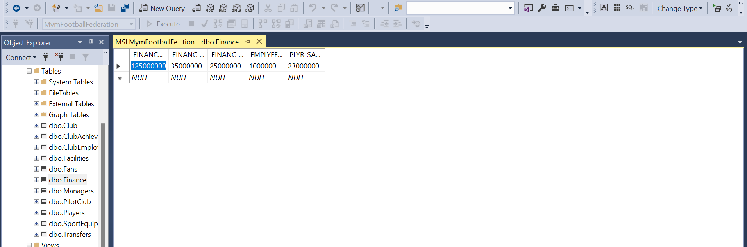

INSERT INTO Managers

VALUES ( 1 , 'MERİÇ' , 'ASLAN' , '5389034587')

metin, ekran görüntüsü, cihaz içeren bir resim

Açıklama otomatik olarak oluşturuldu

INSERT INTO PilotClub

VALUES ( 1, 'Niğde Anadolu FK' , 'ŞAHİNALİ MAH.ŞEHİT FARUK EREN CAD.NO:6 MERKEZ NİĞDE' , 200000 , 'nıgdeanadolufk@gmail.com' , '5432345673')

metin, ekran görüntüsü, cihaz içeren bir resim

Açıklama otomatik olarak oluşturuldu

INSERT INTO Players

VALUES ( 93 , 'SACHA' , 'BOEY' , '2000-09-13' , 'RIGHT BACK' , 15000000 , 'FRANCE' , 'Meriç' , 1000000 , 1)

metin, ekran görüntüsü, iç mekan içeren bir resim

Açıklama otomatik olarak oluşturuldu

INSERT INTO SportEquipments

VALUES ( 23 , 307 , 307 , 614 , 250 , 50 , 2300)

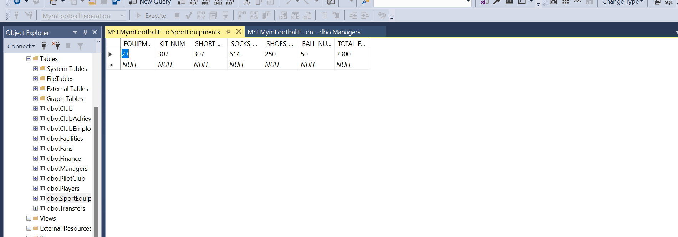

INSERT INTO Transfers VALUES (35 , 5 , 2 , 'MAURO' , 'ICARDI' , 'OMER' , 'BAYRAM')

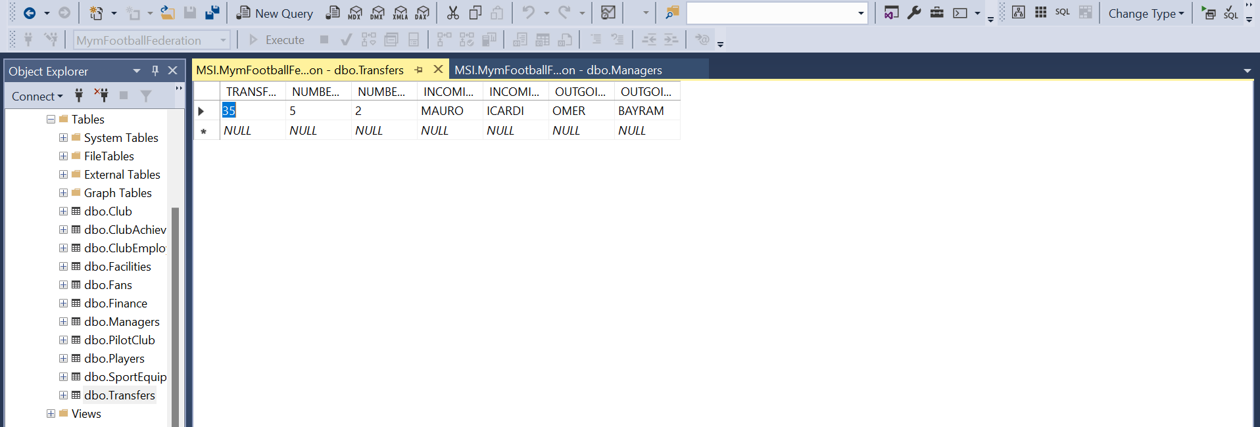

30 Meaningful SQL SELECT Commands

SELECT FINANCE_STAT FROM Finance

WHERE EXISTS

(SELECT FINANC_RECEİVE FROM Finance WHERE FINANC_RECEİVE > FINANC_DEBT)

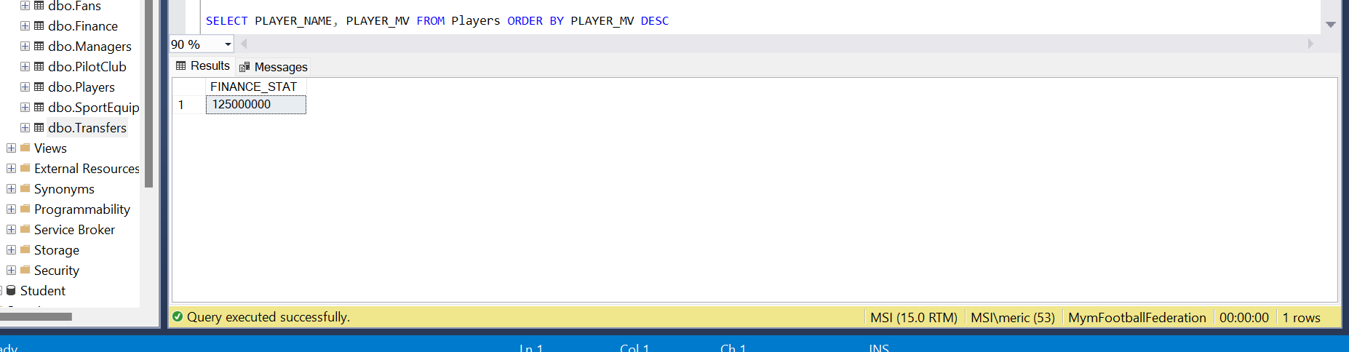

SELECT FINANCE_STAT, SUM(EMPLYEE_SALARY + PLYR_SALARY) AS "Total Salary"

FROM Finance

GROUP BY FINANCE_STAT

HAVING SUM(EMPLYEE_SALARY + PLYR_SALARY) > 100000

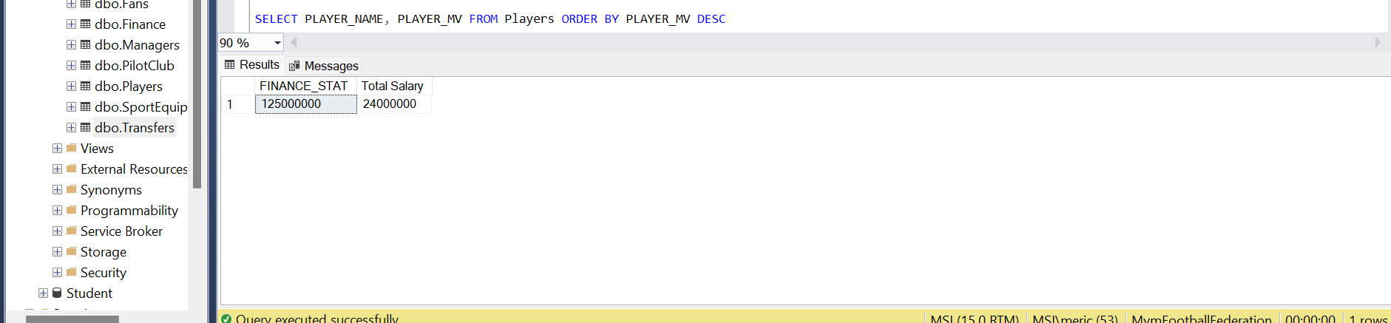

SELECT FINANCE_STAT

FROM Finance

UNION SELECT FINANC_RECEİVE FROM Finance

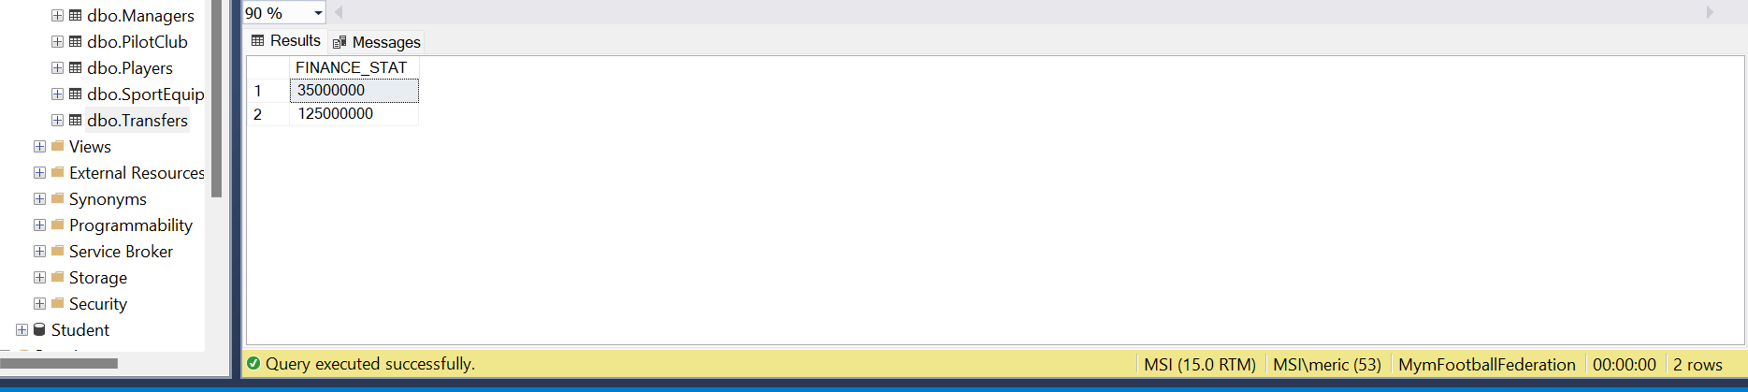

SELECT PLAYER_NAME, PLAYER_MV FROM Players ORDER BY PLAYER_MV DESC

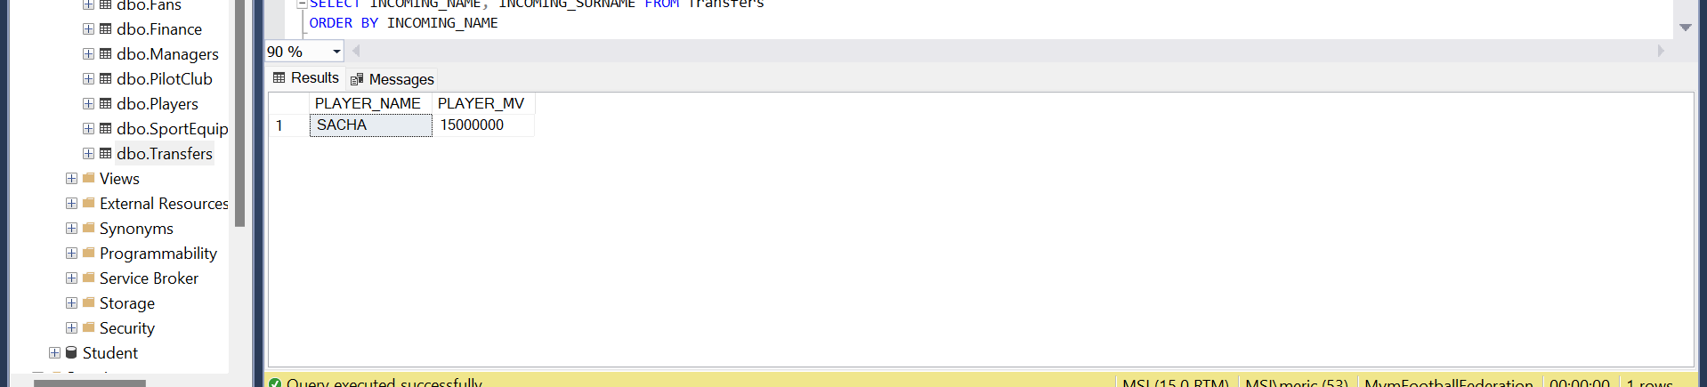

SELECT PLAYER_NAME FROM Players WHERE EXISTS (SELECT PLAYER_MANAGER_NAME FROM Players WHERE PLAYER_MANAGER_NAME='Meriç')

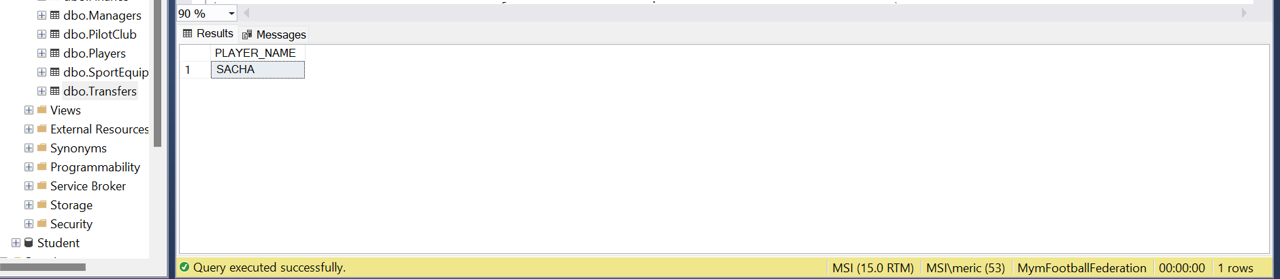

SELECT PLAYER_MANAGER_NAME, SUM(PLAYER_MV) AS "Total Market Value" FROM Players

GROUP BY PLAYER_MANAGER_NAME HAVING SUM(PLAYER_MV) > 10000000

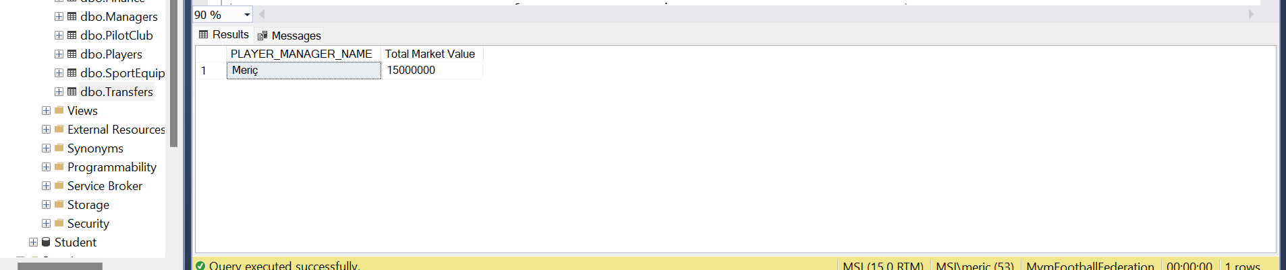

SELECT INCOMING_NAME, INCOMING_SURNAME FROM Transfers

ORDER BY INCOMING_NAME

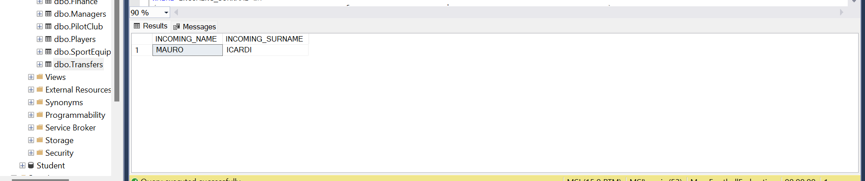

SELECT INCOMING_NAME FROM Transfers

WHERE INCOMING_SURNAME IN

(SELECT DISTINCT INCOMING_SURNAME FROM Transfers WHERE NUMBER_INCOMİNG_PLAYERS > NUMBER_OUTGOING_PLAYERS)

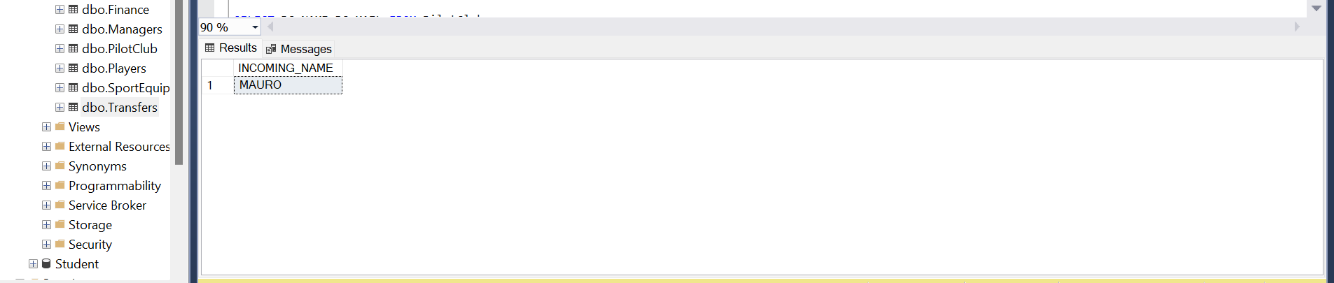

SELECT PC_NAME, PC_MARKET_VALUE

FROM PilotClub

WHERE PC_MARKET_VALUE > 100000

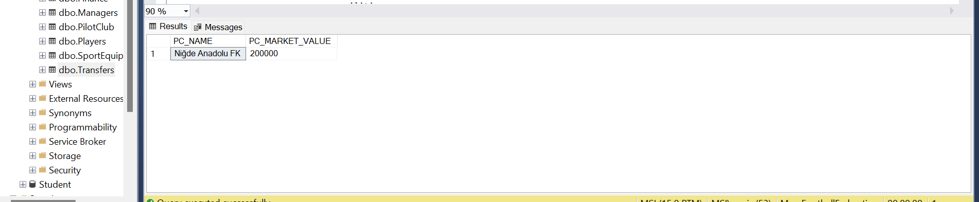

SELECT PC_NAME,PC_MAIL FROM PilotClub

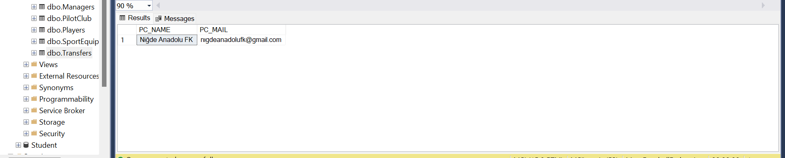

SELECT MANAGER_NAME, MANAGER_SURNAME FROM Managers

WHERE MANAGER_NAME LIKE 'M%'

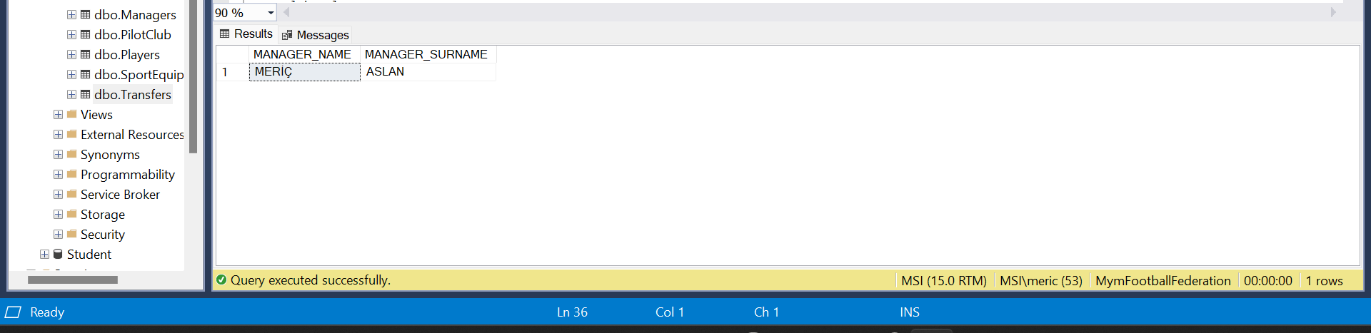

SELECT FACILITY_NAME FROM Facilities

UNION SELECT FACILITY_PHONE FROM Facilities

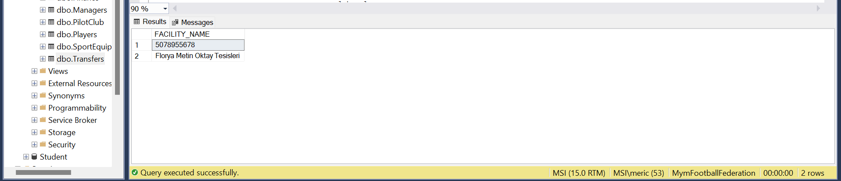

SELECT FACILITY_ADDRESS, COUNT(FACILITY_ID) FROM Facilities

GROUP BY FACILITY_ADDRESS

metin içeren bir resim

Açıklama otomatik olarak oluşturuldu

SELECT EMPLOYEE_NAME, EMPLOYEE_SALARY

FROM ClubEmployees

WHERE EMPLOYEE_SALARY > 30000

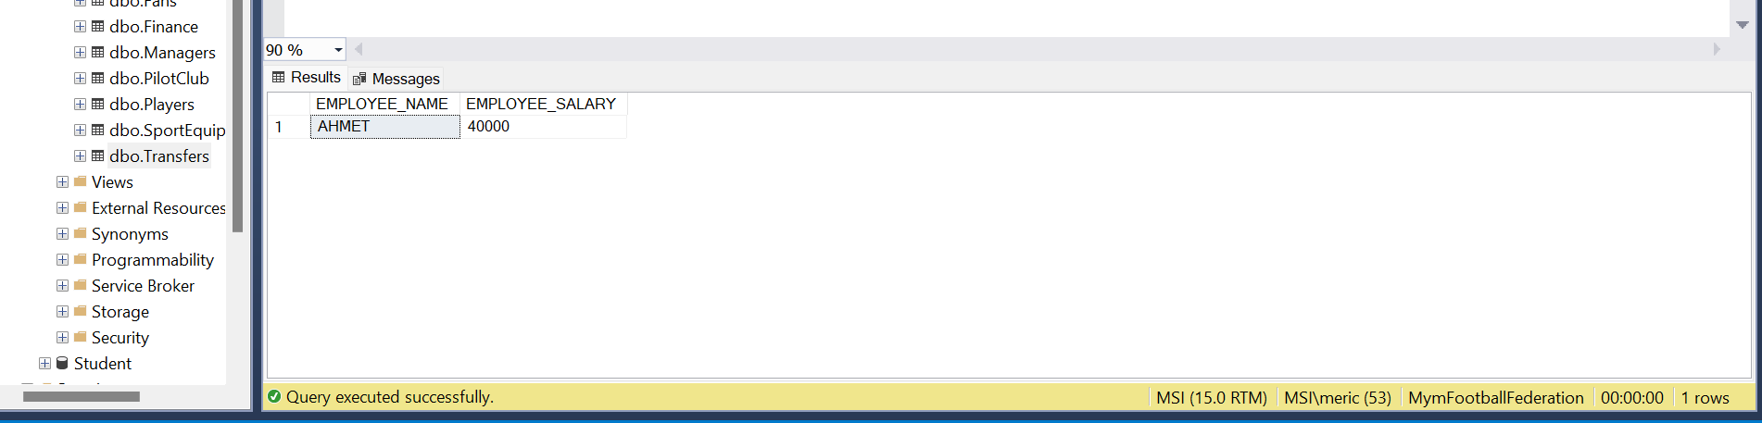

SELECT EMPLOYEE_NAME, EMPLOYEE_SALARY FROM ClubEmployees ORDER BY EMPLOYEE_SALARY DESC

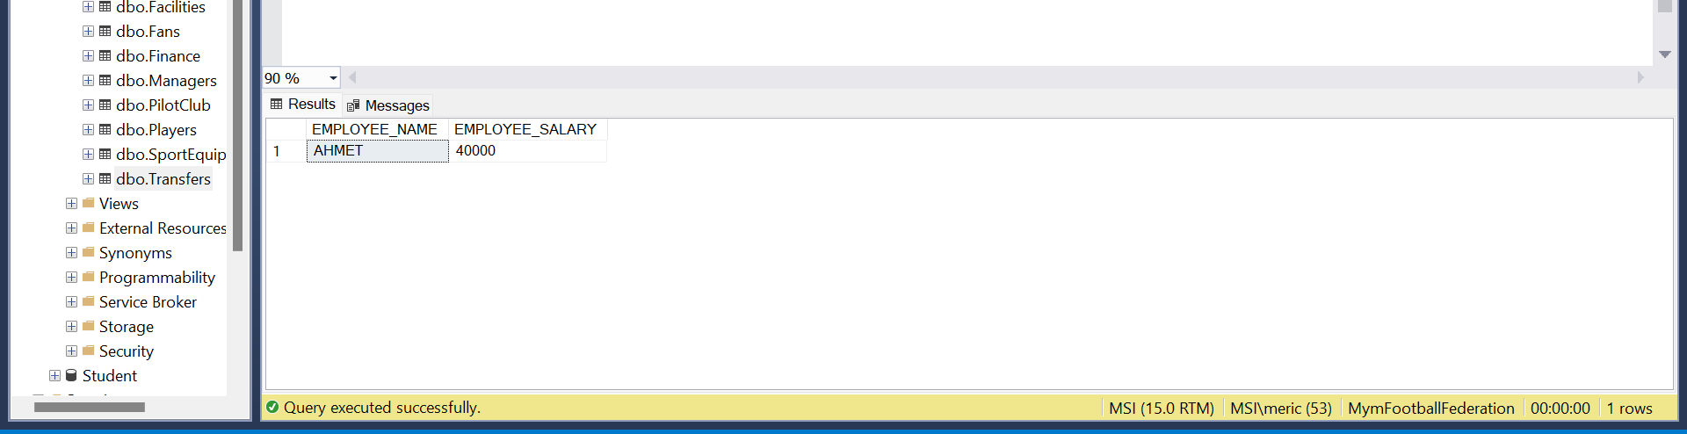

SELECT DISTINCT EMPLOYEE_NAME FROM ClubEmployees UNION SELECT DISTINCT EMPLOYEE_SURNAME FROM ClubEmployees

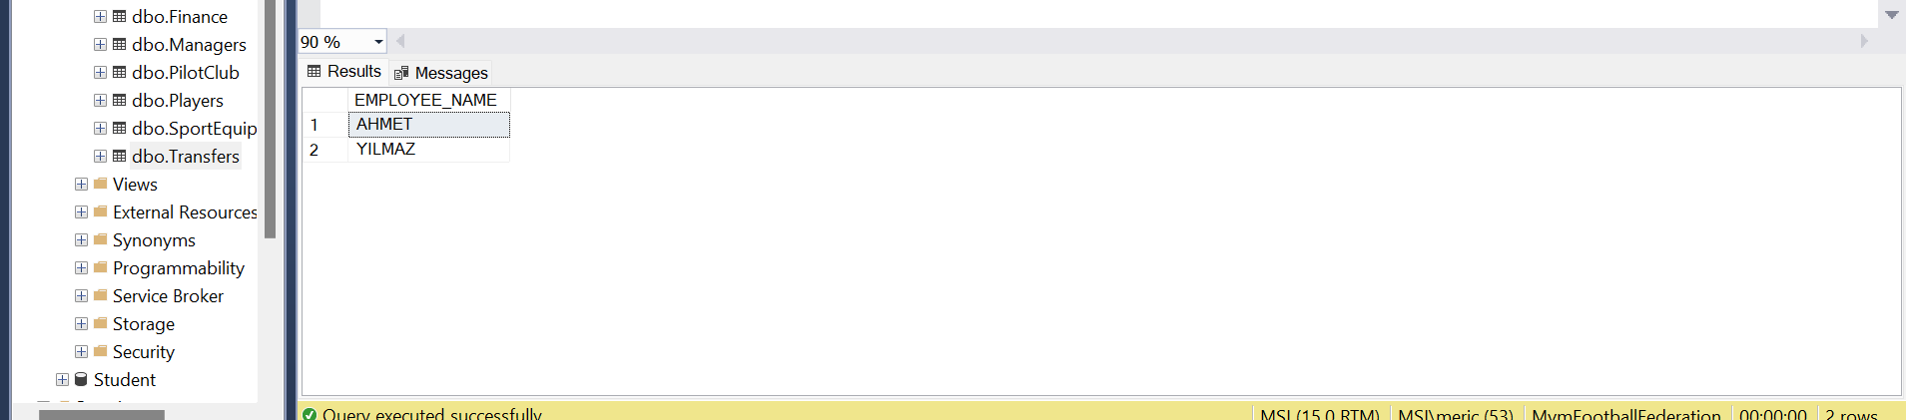

SELECT Players.PLAYER_NAME, Managers.MANAGER_NAME FROM Players INNER JOIN Managers ON Players.MANAGER_ID = Managers.MANAGER_ID

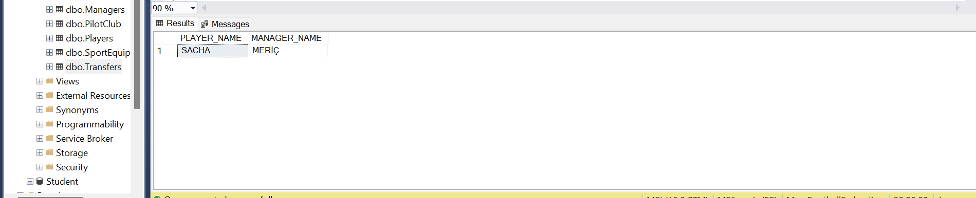

SELECT Players.PLAYER_NAME, Managers.MANAGER_NAME, Managers.MANAGER_PHONE_NUMBER FROM Players

LEFT JOIN Managers ON Players.MANAGER_ID = Managers.MANAGER_ID WHERE Players.PLAYER_POSITION = 'RIGHT BACK'

metin içeren bir resim

Açıklama otomatik olarak oluşturuldu

SELECT Players.PLAYER_NAME, Managers.MANAGER_NAME, Players.PLAYER_MV, Managers.MANAGER_PHONE_NUMBER FROM Players

INNER JOIN Managers ON Players.MANAGER_ID = Managers.MANAGER_ID ORDER BY Players.PLAYER_MV DESC

metin içeren bir resim

Açıklama otomatik olarak oluşturuldu

SELECT Club.CLUB_NAME, Transfers.INCOMING_NAME FROM Club LEFT JOIN Transfers ON Club.TRANSFER_ID = Transfers.TRANSFER_ID

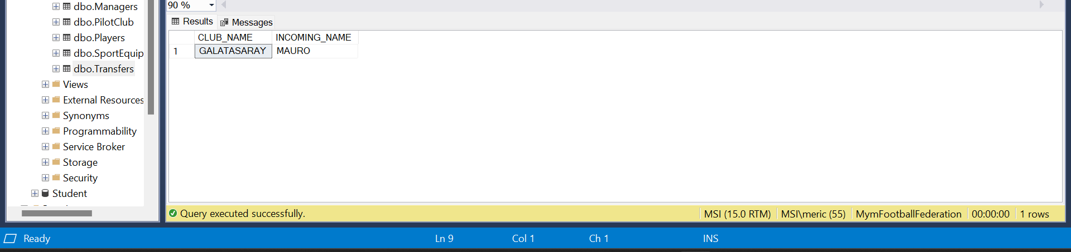

SELECT Club.NUMBER_PLAYER, Transfers.NUMBER_INCOMİNG_PLAYERS FROM Club

LEFT JOIN Transfers ON Club.TRANSFER_ID = Transfers.TRANSFER_ID

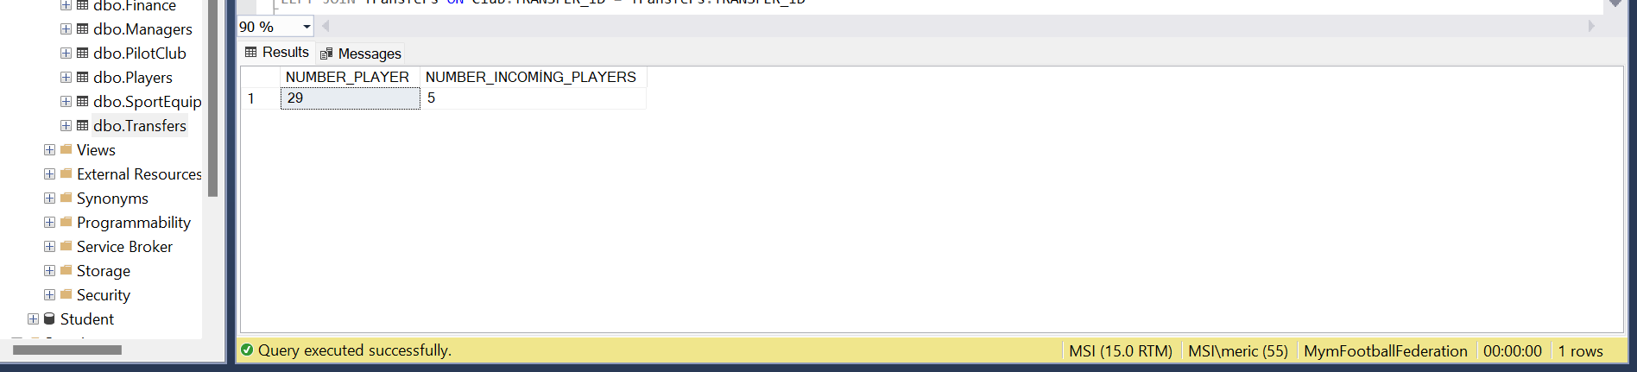

SELECT CLUB_ID, OUTGOING_NAME, OUTGOING_SURNAME FROM Club

LEFT JOIN Transfers ON Club.TRANSFER_ID = Transfers.TRANSFER_ID

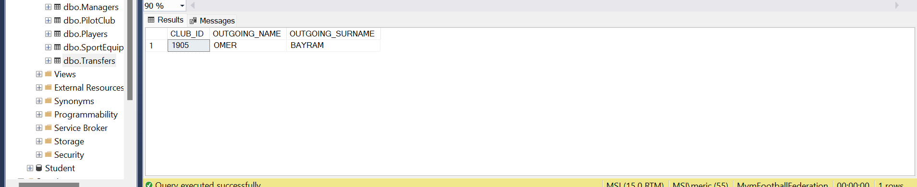

SELECT CLUB_NAME, INCOMING_NAME, INCOMING_SURNAME FROM Club

LEFT JOIN Transfers ON Club.TRANSFER_ID = Transfers.TRANSFER_ID

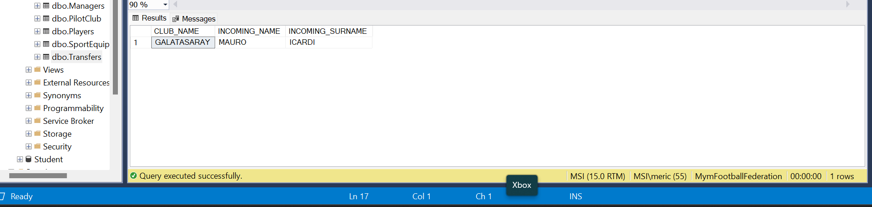

SELECT Club.CLUB_NAME, ClubEmployees.EMPLOYEE_NAME FROM Club

LEFT JOIN ClubEmployees ON Club.EMPLOYEE_ID = ClubEmployees.EMPLOYEE_ID

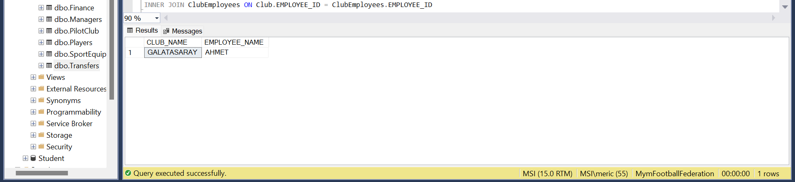

SELECT Club.CLUB_DOB, ClubEmployees.EMPLOYEE_SURNAME FROM Club

INNER JOIN ClubEmployees ON Club.EMPLOYEE_ID = ClubEmployees.EMPLOYEE_ID

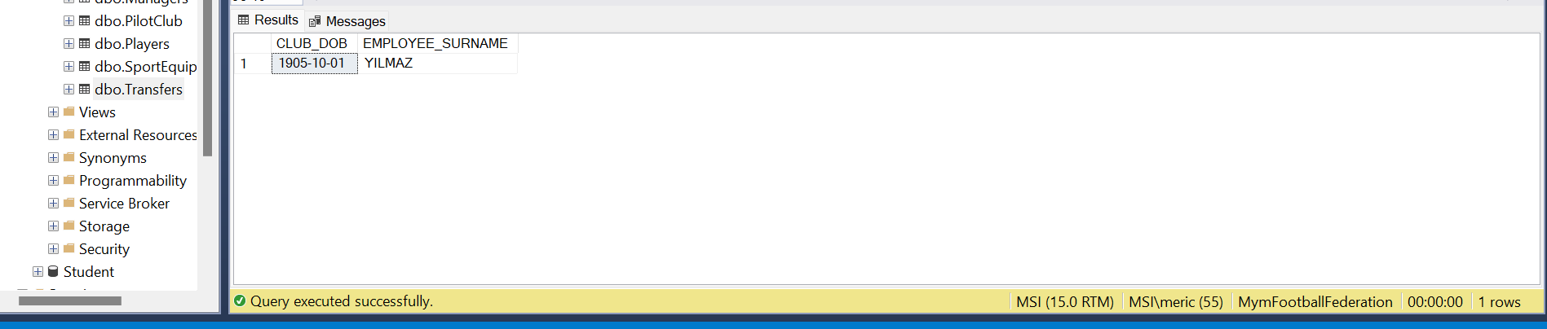

SELECT Club.CLUB_ADDRESS, ClubEmployees.EMPLOYEE_NAME, ClubEmployees.EMPLOYEE_SURNAME FROM Club

INNER JOIN ClubEmployees ON Club.EMPLOYEE_ID = ClubEmployees.EMPLOYEE_ID

metin içeren bir resim

Açıklama otomatik olarak oluşturuldu

SELECT Club_NAME, FINANCE_STAT, PC_NAME FROM Club

INNER JOIN PilotClub ON Club.PILOT_CLUB_ID = PilotClub.PILOT_CLUB_ID

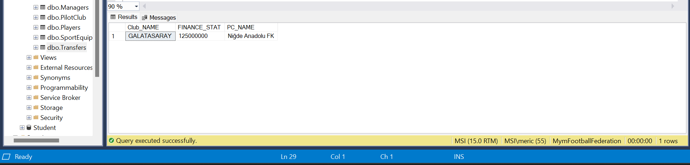

SELECT CLUB_ID, NUMBER_PLAYER, PC_PHONE_NUMBER FROM Club

LEFT JOIN PilotClub ON Club.PILOT_CLUB_ID = PilotClub.PILOT_CLUB_ID

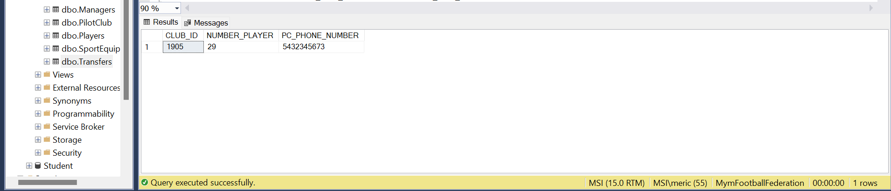

SELECT CLUB_NAME, PC_MARKET_VALUE, PC_MAIL FROM Club

INNER JOIN PilotClub ON Club.PILOT_CLUB_ID = PilotClub.PILOT_CLUB_ID

metin içeren bir resim

Açıklama otomatik olarak oluşturuldu

SELECT Club_ID, PC_ADRESS FROM Club

LEFT JOIN PilotClub ON Club.PILOT_CLUB_ID = PilotClub.PILOT_CLUB_ID

metin içeren bir resim

Açıklama otomatik olarak oluşturuldu

SELECT Club_NAME, PC_NAME FROM Club

INNER JOIN PilotClub ON Club.PILOT_CLUB_ID = PilotClub.PILOT_CLUB_ID

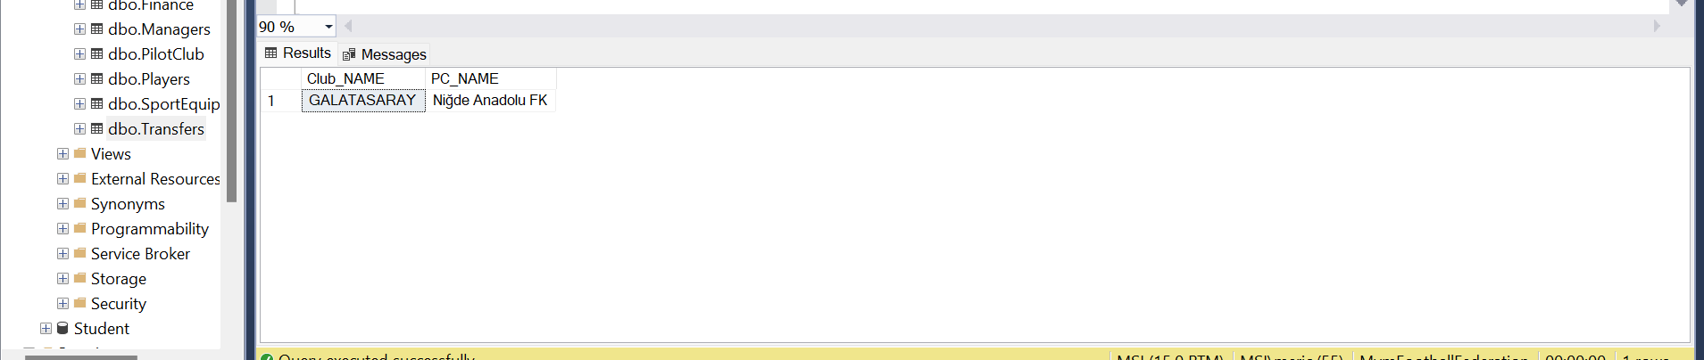

CREATE VİEWS

CREATE VIEW Club_Summary

AS SELECT CLUB_ID, CLUB_NAME, NUMBER_PLAYER, NUMBER_TROPHiES FROM Club

metin içeren bir resim

Açıklama otomatik olarak oluşturuldu

CREATE VIEW Club_Finance

AS SELECT CLUB_NAME, FINANCE_STAT, CLUB_MV FROM Club

metin içeren bir resim

Açıklama otomatik olarak oluşturuldu

CREATE VIEW Club_Contact

AS SELECT CLUB_NAME, CLUB_ADDRESS, CLUB_MAIL FROM Club

metin içeren bir resim

Açıklama otomatik olarak oluşturuldu

CREATE VIEW Club_Players

AS SELECT CLUB_NAME, PLAYER_ID FROM Club

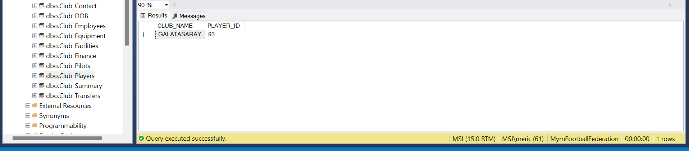

CREATE VIEW Club_Pilots

AS SELECT CLUB_NAME, PILOT_CLUB_ID FROM Club

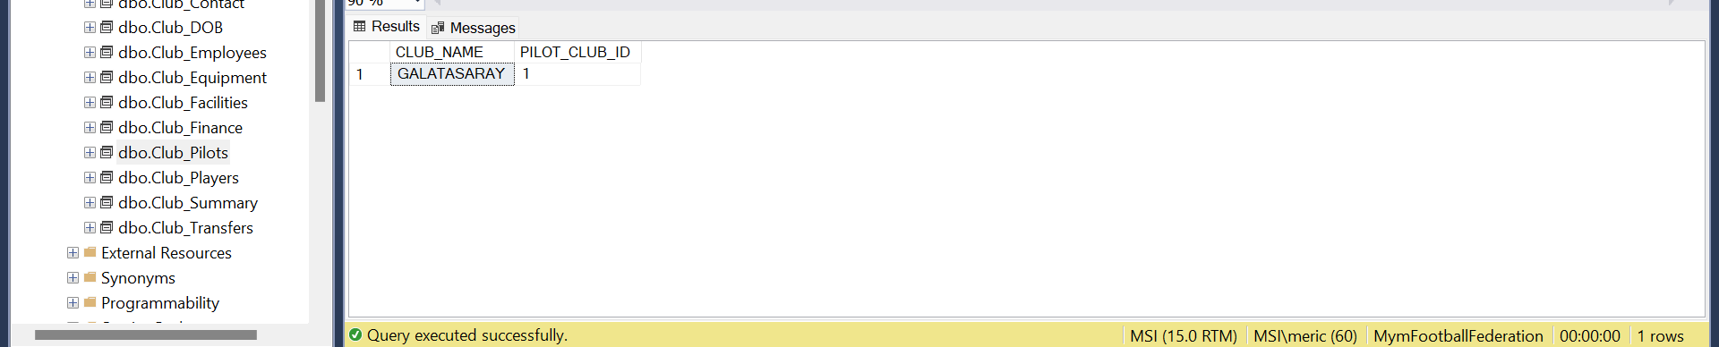

CREATE VIEW Club_Employees

AS SELECT CLUB_NAME, EMPLOYEE_ID FROM Club

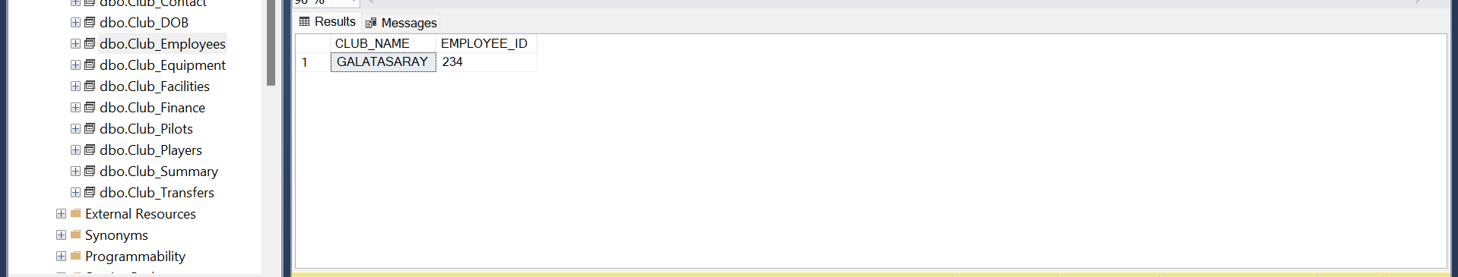

CREATE VIEW Club_Transfers

AS SELECT CLUB_NAME, TRANSFER_ID FROM Club

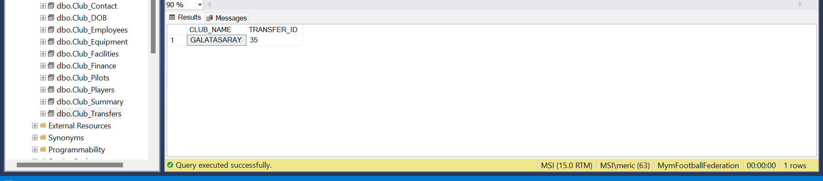

CREATE VIEW Club_Equipment

AS SELECT CLUB_NAME, EQUIPMENT_ID FROM Club

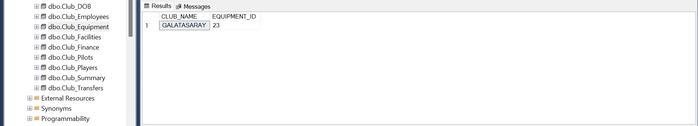

CREATE VIEW Club_Facilities

AS SELECT CLUB_NAME, FACILITY_ID FROM Club

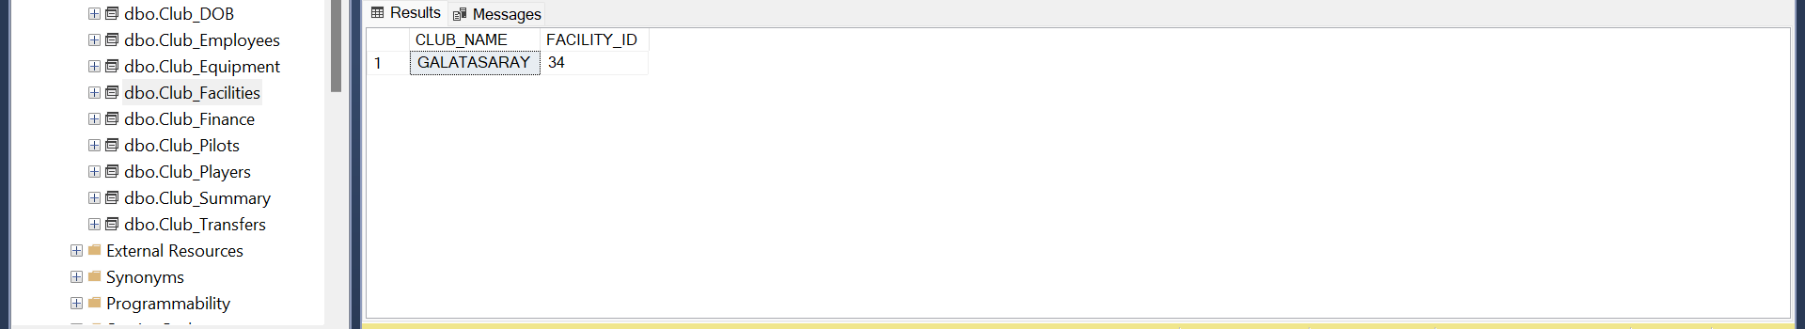

CREATE VIEW Club_DOB

AS SELECT CLUB_NAME, CLUB_DOB FROM Club

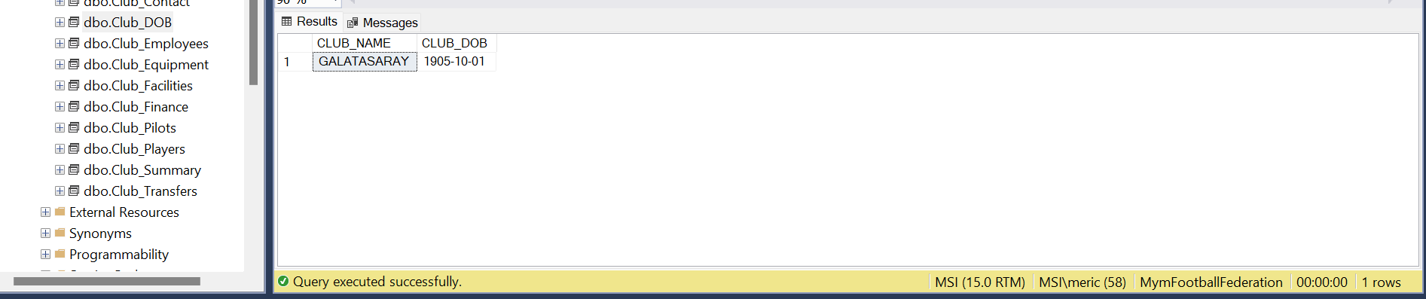

ALTER TABLES

ALTER TABLE Club

ADD Stadium_Name nvarchar(255)

ALTER TABLE Club

ADD Stadium_Capacity int

ALTER TABLE Club

DROP COLUMN Stadium_Capacity

ALTER TABLE Club

ADD FOREIGN KEY (PILOT_CLUB_ID) REFERENCES PilotClub(PILOT_CLUB_ID)

ALTER TABLE Club

DROP COLUMN FINANCE_STAT

DROP TABLES

DROP TABLE Club

DROP TABLE Fans

DROP TABLE Facilities

DROP TABLE Finance

DROP TABLE Managers

UPDATES AND DELETES

UPDATE Club SET CLUB_MV= 168000000

UPDATE PilotClub SET PC_MARKET_VALUE= 284000

UPDATE ClubAchievements SET NUMBER_TROPHİES= 99

UPDATE ClubEmployees SET EMPLOYEE_SALARY= 50000

UPDATE Facilities SET FACILITY_PHONE= '5394543739'

DELETE FROM Club WHERE CLUB_NAME = 'Galatasaray'

DELETE FROM Facilities WHERE FACILITY_ID = 34

DELETE FROM Managers WHERE MANAGER_NAME LIKE 'M%'

DELETE FROM PilotClub WHERE PC_MARKET_VALUE < 300000

DELETE FROM ClubEmployees WHERE EMPLOYEE_DEPARTMENT = 'Doctor'